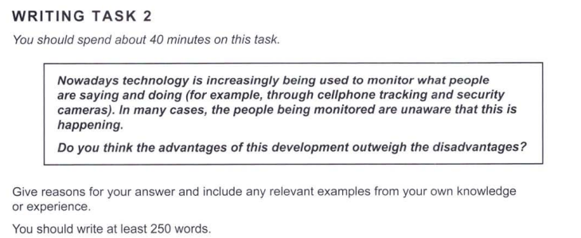

Essay Response:

With rapid technological advancements being made in recent decades, privacy has increasingly become a significant concern for people buying new products. This is a complex issue with many moral and ethical concerns, and is hard to navigate for many. In my opinion, there is no clear way in which the benefits of such technology outweigh the limitations, or vice versa. To illustrate this, we must consider three points.

Firstly, security cameras are being used in many public spaces, such as roads and apartment building lobbies, and are installed with an intent to deter burglars. Some cameras have been designed to be ‘hidden’ in that they are small and barely visible to passers-by. However, such cameras have been used by some Airbnb (a service to rent/stay in homes) hosts to spy on their clients, in often immoral ways. While the greater security that this technology can provide is amazing, the way in which it can be abused is a disadvantage to keep in mind.

Secondly, cellphone tracking may be used for nefarious purposes like stalking, but could also be beneficial in ways like the ‘Find my Phone’ application that most contemporary phones have, to locate lost phones. Such applications could also be used to track a friend, in case they travel to places which are unsafe or easy to get lost in. Hence, tracking mechanisms could have both positive and negative uses; it would be hard to conclusively say that it is completely ‘bad’ or ‘good.’

Finally, we must consider the people who do not know about these monitoring devices. The developments made in such technologies do not have to cease, but could notify and request people to share their location, if needed. As much as possible, explicit info could be provided to consumers, in order to prevent illegal or immoral use.

Hence, the given issue is not a black-and-white one, and the advantages and disadvantages seem to evenly cancel each other out. Each of these depends on the degree of regulations enforced on different aspects of these technologies.